Assignment 1 : Version Control with Git

**Step 1 – Create a local git repository**

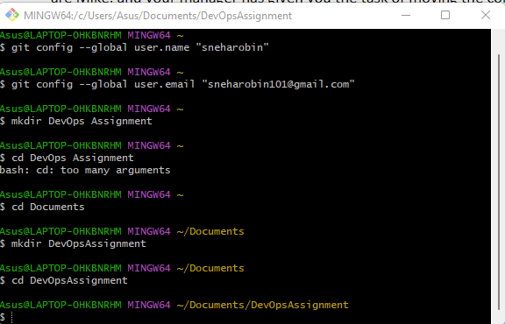

**Step 2 – Initialize the repository and add the code base to the local**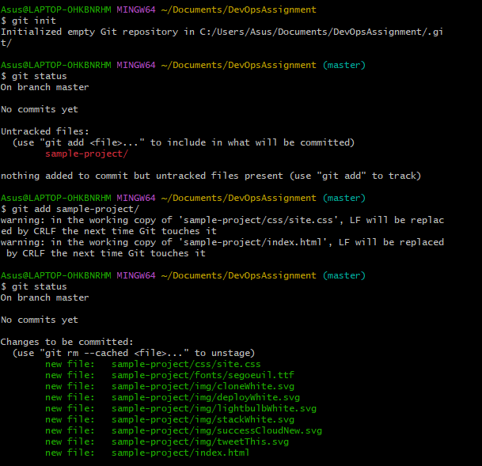

**Step 3 – Commit the added code base to the local repository**

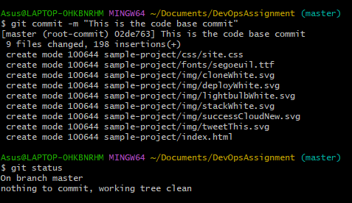

**Step 4 – Push the code from local repository to the remote repository**

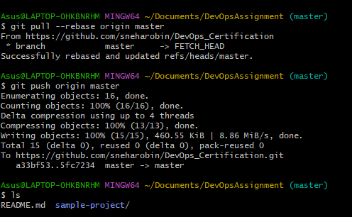

**Step 5 – Add a new file and push the code to remote repository**

